Self-study, Lesson 9, April 17

EN Version/SK Verzia: Recycling/recyklovanie

Objective: I can speak about rubbish, different materials and how to recycle them
There are a lot of words which mean „odpad, odpadky, atď“. Most of them are interchangeable.
waste – odpad (niečo nepoužiteľné, to čo zostane po nejakom procese ako zvyšok)
garbage, trash – AmE (smeti)
rubbish – BrE (smeti)
litter – odpadky na ulici
Ešte viac možností existuje na vyjadrenie smetného koša, napr.
waste bin, rubbish bin, litter bin, dustbin, garbage can, trash can, container, dumpster etc.
What are the blue / yellow / green/ black / red / brown bins for?
Match the words with the pictures and write the words in the table: face cream pot, wine bottle, food tin, drink cans, left-overs, shampoo bottle, cardboard boxes, shop receipts, egg boxs, toilet/kitchen roll tubes

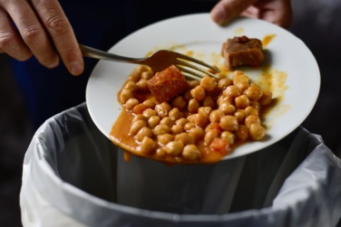
Blue bin | Yellow bin | Green bin | Black bin | Red bin | Brown bin

Ísť so smeťami/vyhodiť smeti – take out the trash. Who takes out the trash in your family?

Tasks on page 76, 8C. Before you do them, learn the vocabulary from this worksheet
- Read the text and find out why they are proud of their dustbin.
- Do ex. 3, read the questions, read the text again and answer the questions in your notebook.
- Do ex. 4 –all phrases are used in the text!

Further homework:
WB – p. 72/1,2,3
Write me an email at englishsosban@gmail.com (6-10 sentences) about rubbish and recycling in your family.
- Do you recycle? What?
- What do you do to help nature and the environment? Do you save energy? How? Are you trying to reduce the use of plastic? How?
- Do you make compost? Use rechargeable batteries? Use a cloth shopping bag etc.?

