Easter
Easter (also called Pascha)
- is a festival and holiday commemorating the resurrection of Jesus from the dead
- is celebrated (differently) in many countries by both Christians and non-Christians
- in both Christian and pagan traditions, Easter is related to spring and new life
- in Western Christianity it is preceded by Lent, a period of fasting and penitence in preparation for Easter, which begins on Ash Wednesday and lasts 40 days (not counting Sundays)
- The week before Easter is known as Holy Week
- various traditions are connected with this holiday
  - America – Easter egg hunts
  - the UK – Egg rolling
  - Australia – Easter Bilby delivers Easter eggs (not Easter bunny, rabbits are considered pests here)
  - Slovakia, Czech republic – unique traditions
    - males spank females lightly with a homemade willow whip decorated with ribbons
    - men also dump cold water on women
    - all this is said to bring health to girls over the next year
- Match the words with the phrases in green.
Pôstne obdobie, Veľký týždeň, Popolcová streda, Zmŕtvychvstanie, postenie sa
- Match the pictures with the traditions a), b), c), d)
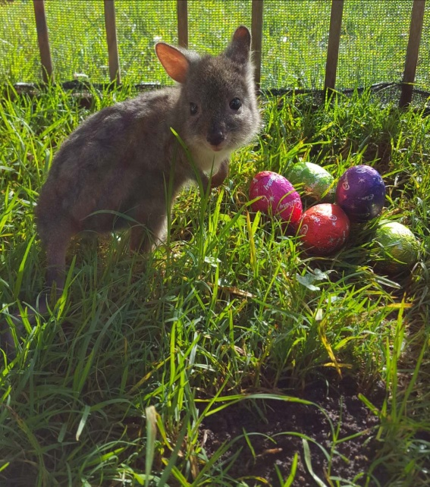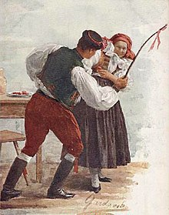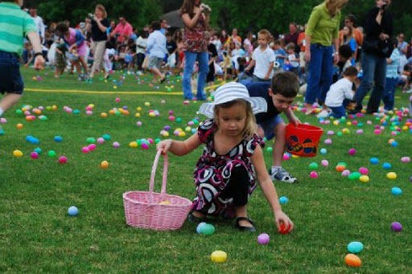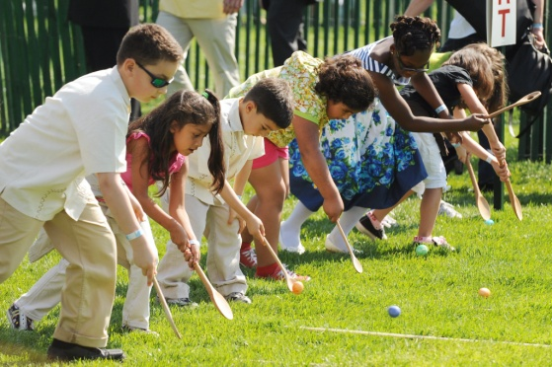

Holy Week
Easter is the most important festival in the Christian calendar. It celebrates the resurrection from the dead of Jesus, three days after he was executed. The Easter story is at the heart of Christianity.
The week leading up to Easter is called Holy Week.

Holy Week
Palm Sunday
- This is the Sunday before Easter Day.
- It is the first day of Holy Week and celebrates Jesus' arrival in Jerusalem riding on a donkey.
- Crowds of people came out of the city to greet him, throwing down palm branches on the road.
Maundy Thursday (also Holy Thursday)
- This is the Thursday before Easter Day
- Last Supper: On Maundy Thursday Christians remember when Jesus ate the Passover meal with his disciples, breaking bread and drinking wine, which is now known as the Last Supper.
- At this meal Jesus told his followers that they should love and serve one another. He demonstrated this by washing the feet of the disciples - something a servant would normally do. You can read this story in the Bible in John Chapter 13 verse 1-15
- The word maundy comes from the command (mandate) given by Jesus at the Last Supper, that we should love one another.
- Roman Catholic church services include a ceremony in which the priest washes the feet of 12 people to commemorate Jesus' washing the feet of his disciples.
Good Friday
- Good Friday is the Friday before Easter Sunday. It commemorates the execution of Jesus by crucifixion.
- Good Friday is a day of mourning in church. During special Good Friday services Christians remember Jesus' suffering and death on the cross, and what this means for their faith.
- In some countries, there are special Good Friday processions and people pray the Stations of the Cross
- People also abstain from meat and fast (eat only 1 regular meal and 2 smaller meals – half the size of what they would normally have) on this day
Holy Saturday (Black Saturday)
- Holy Saturday is the day between the crucifixion of Jesus and his resurrection.
- In the Catholic tradition, Mass is not celebrated.
- The celebration of Easter begins after sundown on what, though still Saturday in the civil calendar, is liturgically Easter Sunday.
Easter Sunday / Easter Day
- Follows the Holy Week
- Is the great feast day
- The Resurrection of Jesus Christ is celebrated
- It is the first day of the new season of the Great Fifty Days, or Eastertide, which runs from Easter Day to Pentecost Sunday

- Write the English names of these holidays:
Kvetná nedeľa -
Zelený štvrtok -
Veľký piatok -
Biela sobota -
Veľkonočná nedeľa/Veľká noc –
- Match the pictures with the English names of the days from previous exercise.
Picture | Day
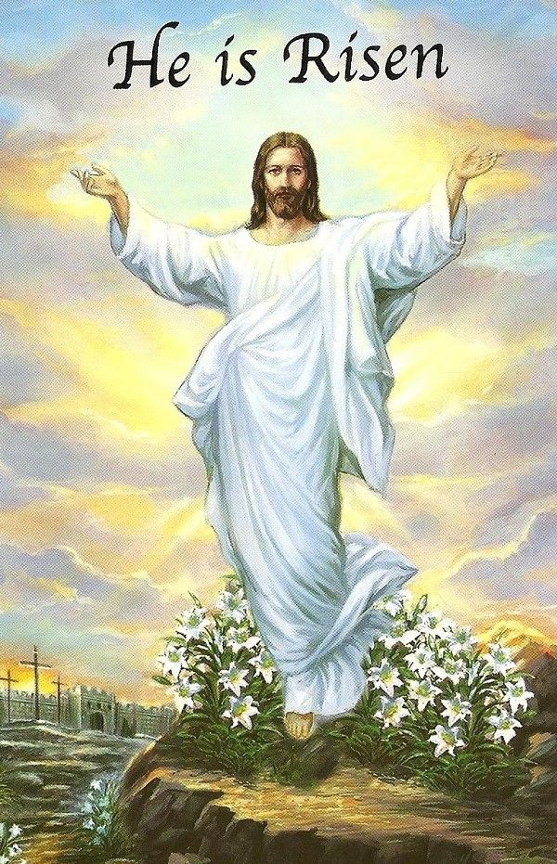
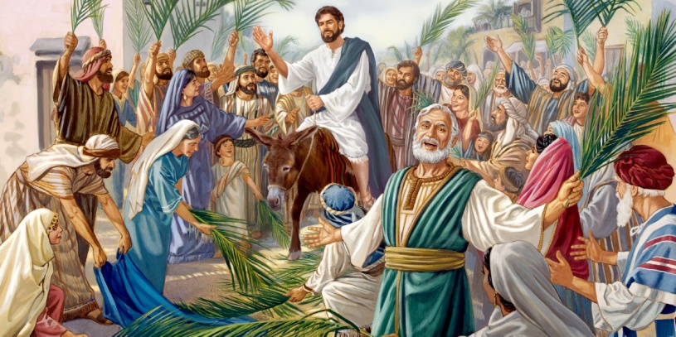
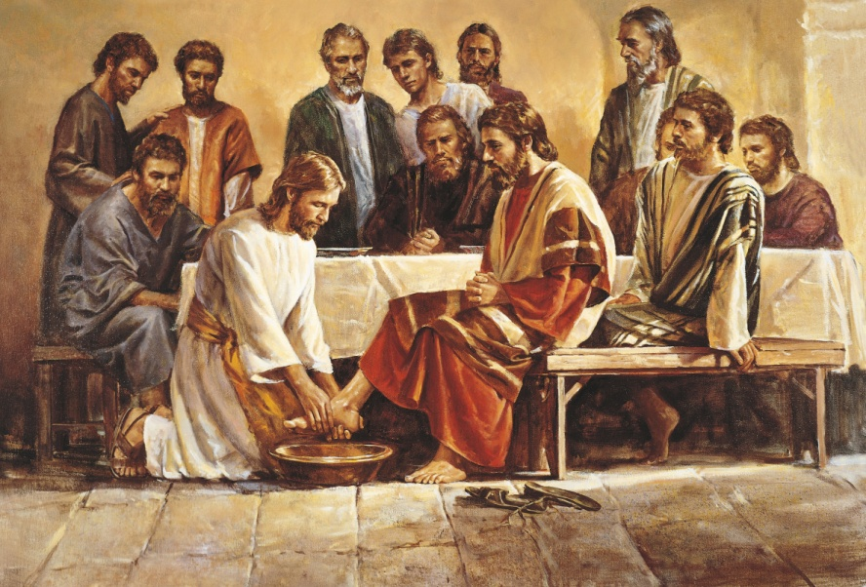
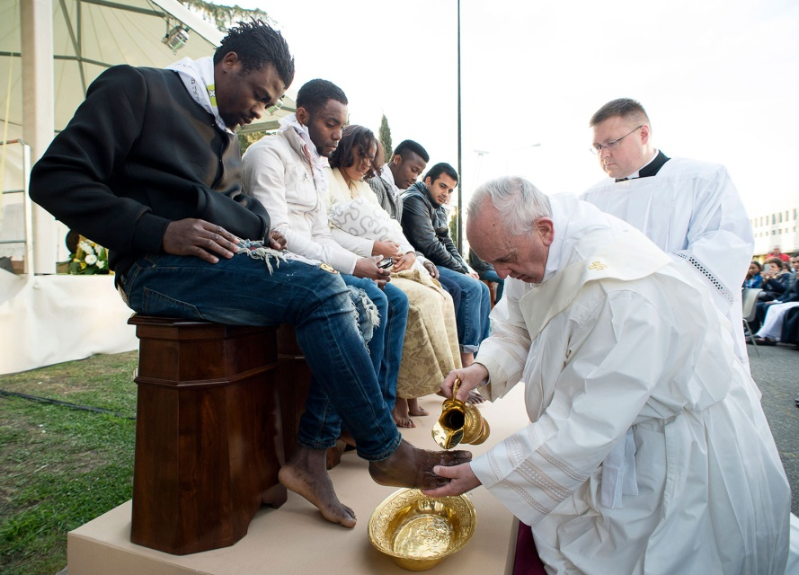
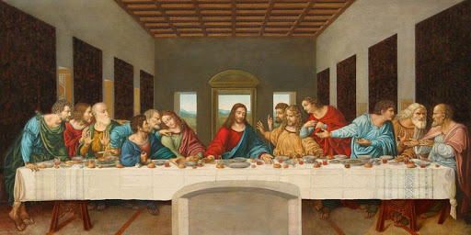
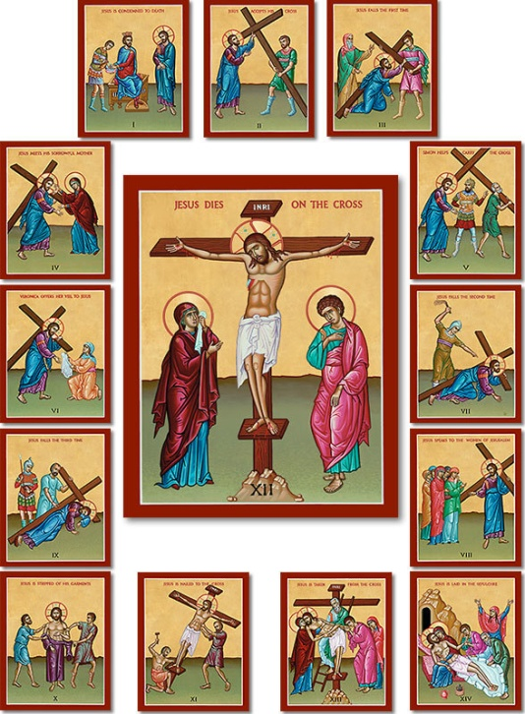

BONUS QUESTION: Is Easter day always the same date?
Look at past and future Easter days:
Table of dates of Easter 2001–2025 ]
Year | Full Moon | Jewish Passover | Astronomical Easter | Gregorian Easter | Julian Easter
2001 | 8 April |  | 15 April
2002 | 28 March |  | 31 March |  | 5 May
2003 | 16 April | 17 April | 20 April |  | 27 April
2004 | 5 April | 6 April | 11 April
2005 | 25 March | 24 April | 27 March |  | 1 May
2006 | 13 April |  | 16 April |  | 23 April
2007 | 2 April | 3 April | 8 April
2008 | 21 March | 20 April | 23 March |  | 27 April
2009 | 9 April |  | 12 April |  | 19 April
2010 | 30 March |  | 4 April
2011 | 18 April | 19 April | 24 April
2012 | 6 April | 7 April | 8 April |  | 15 April
2013 | 27 March | 26 March | 31 March |  | 5 May
2014 | 15 April |  | 20 April
2015 | 4 April |  | 5 April |  | 12 April
2016 | 23 March | 23 April | 27 March |  | 1 May
2017 | 11 April |  | 16 April
2018 | 31 March |  | 1 April |  | 8 April
2019 | 21 March | 20 April | 24 March | 21 April | 28 April
2020 | 8 April | 9 April | 12 April |  | 19 April
2021 | 28 March |  | 4 April |  | 2 May
2022 | 16 April |  | 17 April |  | 24 April
2023 | 6 April |  | 9 April |  | 16 April
2024 | 25 March | 23 April | 31 March |  | 5 May
2025 | 13 April |  | 20 April

The key to calculate the Easter day: It is the first Sunday after the full moon that occurs on or soonest after 21 March.
Learn all the new vocabulary related to Easter.
Happy Easter :)

pohanské
bandikut - zviera
korbáč (z vŕby)
Krížová cesta (aj Way of the Cross)

