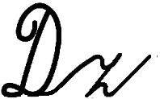
Meno a priezvisko........................................................ Trieda..................

_______________________________________________________________________________________________

_______________________________________________________________________________________________

_______________________________________________________________________________________________

_______________________________________________________________________________________________

_______________________________________________________________________________________________

_______________________________________________________________________________________________

_______________________________________________________________________________________________
Meno a priezvisko........................................................ Trieda..................
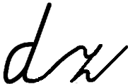

_______________________________________________________________________________________________

_______________________________________________________________________________________________

_______________________________________________________________________________________________

_______________________________________________________________________________________________

_______________________________________________________________________________________________

_______________________________________________________________________________________________

_______________________________________________________________________________________________

Meno a priezvisko........................................................ Trieda..................

_______________________________________________________________________________________________

_______________________________________________________________________________________________

_______________________________________________________________________________________________

_______________________________________________________________________________________________

_______________________________________________________________________________________________

_______________________________________________________________________________________________

_______________________________________________________________________________________________

Meno a priezvisko........................................................ Trieda..................

_______________________________________________________________________________________________

_______________________________________________________________________________________________

_______________________________________________________________________________________________

_______________________________________________________________________________________________

_______________________________________________________________________________________________

_______________________________________________________________________________________________

_______________________________________________________________________________________________

